[NaturalPoint Product Documentation Ver 2.0](https://v20.wiki.optitrack.com/index.php?title=Main_Page)

The Devices pane can be accessed under the View tab in Motive or by clicking [Toolbar Device Icon.png](https://v20.wiki.optitrack.com/index.php?title=File:Toolbar_Device_Icon.png) icon on the main toolbar.

**Contents**

 [[hide](https://v20.wiki.optitrack.com/index.php?title=Devices_pane)]

* [1 Camera Settings](https://v20.wiki.optitrack.com/index.php?title=Devices_pane#Camera_Settings)
  + [1.1 Frame Rate (FPS)](https://v20.wiki.optitrack.com/index.php?title=Devices_pane#Frame_Rate_.28FPS.29)
  + [1.2 Exposure (EXP)](https://v20.wiki.optitrack.com/index.php?title=Devices_pane#Exposure_.28EXP.29)
  + [1.3 Threshold (THR)](https://v20.wiki.optitrack.com/index.php?title=Devices_pane#Threshold_.28THR.29)
  + [1.4 LED Illumination (LED)](https://v20.wiki.optitrack.com/index.php?title=Devices_pane#LED_Illumination_.28LED.29)
  + [1.5 Tracking Mode](https://v20.wiki.optitrack.com/index.php?title=Devices_pane#Tracking_Mode)
  + [1.6 Reference Mode](https://v20.wiki.optitrack.com/index.php?title=Devices_pane#Reference_Mode)
  + [1.7 Gain](https://v20.wiki.optitrack.com/index.php?title=Devices_pane#Gain)
* [2 Device Properties](https://v20.wiki.optitrack.com/index.php?title=Devices_pane#Device_Properties)
  + [2.1 Device Properties: Tracking Group](https://v20.wiki.optitrack.com/index.php?title=Devices_pane#Device_Properties:_Tracking_Group)
  + [2.2 Device Properties: Camera](https://v20.wiki.optitrack.com/index.php?title=Devices_pane#Device_Properties:_Camera)
  + [2.3 Device Properties: Force Plate / Force Plate Group](https://v20.wiki.optitrack.com/index.php?title=Devices_pane#Device_Properties:_Force_Plate_.2F_Force_Plate_Group)
  + [2.4 Device Properties: NI-DAQ Device](https://v20.wiki.optitrack.com/index.php?title=Devices_pane#Device_Properties:_NI-DAQ_Device)
  + [2.5 Device Properties: NI-DAQ Channel](https://v20.wiki.optitrack.com/index.php?title=Devices_pane#Device_Properties:_NI-DAQ_Channel)

**Camera Settings**[[edit](https://v20.wiki.optitrack.com/index.php?title=Devices_pane&action=edit&section=1)]

[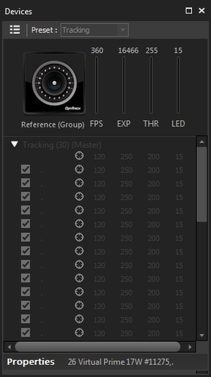](https://v20.wiki.optitrack.com/index.php?title=File:Camera_Pane.png)

Devices pane in Motive.

*Frame Rate (FPS)[*[*edit*](https://v20.wiki.optitrack.com/index.php?title=Devices_pane&action=edit&section=2)*]*

The number of frames the camera or camera group will capture per second. The minimum and maximum values for frame rate depend on the model of camera that you are using. A higher frame rate will allow for more frames per second of data, and help prevent motion blur. A lower frame rate will allow for higher exposure values (and brighter images) and will also reduce the bandwidth required to transmit data, which can help in systems with high network or USB traffic.

|  |  |
| --- | --- |
| [Warning2.png](https://v20.wiki.optitrack.com/index.php?title=File:Warning2.png) | **Note for Flex 3 Systems:** There is a known issue where adjusting system frame rates under the Devices pane does not modify the sampling rate. To adjust frame rates in Flex 3 camera systems, go to the [Synchronization pane](https://v20.wiki.optitrack.com/index.php?title=Custom_Synchronization:_OptiHub#Synchronization_Control), switch to custom synchronization mode, make sure **Sync Mode → OptiSync** is set, input desired frame rate under the **Internal Sync Freq (Hz)** entry, and apply the customized sync configuration. |

*Exposure (EXP)[*[*edit*](https://v20.wiki.optitrack.com/index.php?title=Devices_pane&action=edit&section=3)*]*

Sets the amount of time that the camera exposes per frame. The minimum and maximum values will depend on both the type of camera and the frame rate. Higher exposure will allow more light in, creating a brighter image that can increase visibility for small and dim markers. However, setting exposure too high can introduce false markers, larger marker blooms, and marker blurring--all of which can negatively impact marker data quality. Exposure value is measured in scanlines for V100 and V120 series cameras, and in microseconds for Flex13, S250e and Prime Series cameras.

*Threshold (THR)[*[*edit*](https://v20.wiki.optitrack.com/index.php?title=Devices_pane&action=edit&section=4)*]*

Defines the minimum brightness for a pixel to be seen by a camera, with all pixels below the threshold being ignored. Increasing the threshold can help filter interference by non-markers (e.g. reflections and external light sources), while lowering the threshold can allow dimmer markers to be seen by the system (e.g. smaller markers at longer distances from the camera).

*LED Illumination (LED)[*[*edit*](https://v20.wiki.optitrack.com/index.php?title=Devices_pane&action=edit&section=5)*]*

Sets brightness level for the camera IR LED ring. Higher LED values allow the camera to emit more IR light, which can allow for better marker detection at longer ranges. However, a value that is too high may cause reflection off of non-marker objects, which can destabilize data. Generally, the value should be higher for larger volumes and lower for smaller volumes. Default is dependent on camera model.

*Tracking Mode[*[*edit*](https://v20.wiki.optitrack.com/index.php?title=Devices_pane&action=edit&section=6)*]*

This icon indicates that the camera or camera group is in Tracking mode. Clicking on this will change the camera or camera group to Reference mode.

*Reference Mode[*[*edit*](https://v20.wiki.optitrack.com/index.php?title=Devices_pane&action=edit&section=7)*]*

This icon indicates that the camera or camera group is in [Reference mode](https://v20.wiki.optitrack.com/index.php?title=Data_Recording#Reference_Videos), while it is recording video, will not be tracking markers. Clicking on this will set the camera or camera group to Tracking mode.

*Gain[*[*edit*](https://v20.wiki.optitrack.com/index.php?title=Devices_pane&action=edit&section=8)*]*

Increasing a camera’s gain will brighten the image, which can improve tracking range at very long distances. Higher gain levels can introduce noise into the 2D camera image, so gain should only be used to increase range in very large setup areas, when changing illumination, exposure, and threshold are not sufficient.

**Device Properties**[[edit](https://v20.wiki.optitrack.com/index.php?title=Devices_pane&action=edit&section=9)]

Depending on which item is selected under the **Devices pane**, corresponding properties will show up at the bottom of the pane.

|  |  |
| --- | --- |
| [Info2.png](https://v20.wiki.optitrack.com/index.php?title=File:Info2.png) | All of the devices properties are persisted between different launches of Motive. These properties will be saved under the [Profile XML](https://v20.wiki.optitrack.com/index.php?title=Motive_Basics#Profile_XML_File) file. |

Device Properties: Tracking Group[[edit](https://v20.wiki.optitrack.com/index.php?title=Devices_pane&action=edit&section=10)]

[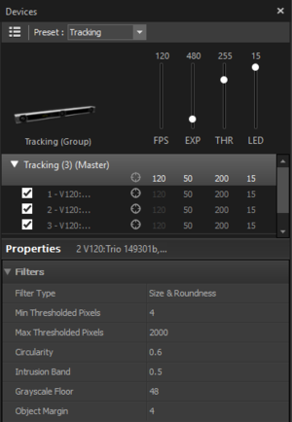](https://v20.wiki.optitrack.com/index.php?title=File:Reconstruction_2DObjectFilter_20.png)

2D Object Filter section in the [Reconstruction Settings](https://v20.wiki.optitrack.com/index.php?title=Reconstruction_Settings) pane.

The following properties can be configured when the Tracking group is selected from the Devices pane. This properties section configures properties for the whole camera system.

*Filters (2D Object Filter)[*[*edit*](https://v20.wiki.optitrack.com/index.php?title=Devices_pane&action=edit&section=11)*]*

When a frame of image is captured by a camera, the 2D Object Filter is applied. By judging on sizes and shapes of the detected reflections, this filter determines which of them can be accepted as marker reflections. Parameters for the 2D Object filter are configured in the **Devices pane** under the Filters section.

|  |  |
| --- | --- |
| [Info2.png](https://v20.wiki.optitrack.com/index.php?title=File:Info2.png) | For Motive 2.0 and above. The 2D Object filter settings in the Reconstruction Settings pane have been moved over to the **Devices pane**. |

**Filter Type**[[edit](https://v20.wiki.optitrack.com/index.php?title=Devices_pane&action=edit&section=12)]

Default: Size and Roundness

Toggles 2D object (Size and Roundness) filtering on or off.

This filter is very useful for filtering out extraneous reflections according to their characteristics (size and roundness) rather than blocking pixels using the masking tool or the Block Visible feature. Turn off this setting only when you want to use every 2D pixels above the brightness threshold from camera views. When there are extraneous or flickering reflections in the view, turn on the filter to specify and consider reflections only from markers. There are multiple filtering parameters to distinguish the marker reflections. Given that there are assumed marker characteristics, filtering parameters can be set. The size parameters can be defined to filter out extra-small or extra-large reflections that are most likely from extraneous sources other than markers. Non-circular reflections can be ignored assuming that all reflective markers have circular shapes. Note that even when applying the size and roundness filter, you should always Block Visible when you calibrate.

[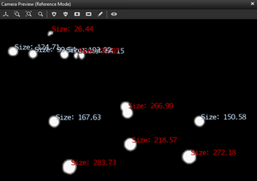](https://v20.wiki.optitrack.com/index.php?title=File:Reconstruction_Size.png)

The size filter applied with a maximum size limit of 200 pixels. Any reflections bigger than 200 pixel-size is omitted from the Point Cloud reconstruction calculation.

**Min Thresholded Pixels (pixels)**[[edit](https://v20.wiki.optitrack.com/index.php?title=Devices_pane&action=edit&section=13)]

Default: 4 pixels

The minimum pixel size of a 2D object, a collection of pixels grouped together, for it to be included in the Point Cloud reconstruction. All pixels must first meet the brightness threshold defined in the Cameras pane in order to be grouped as a 2D object. This can be used to filter out small reflections that are flickering in the view. The default value for the minimum pixel size is 4, which means that more than 4 pixels need a group of pixels needs to be greater than 4 for a ray to be generated.

**Max Thresholded Pixels (pixels)**[[edit](https://v20.wiki.optitrack.com/index.php?title=Devices_pane&action=edit&section=14)]

Default: 2000 pixels

The maximum size of a 2D object, in pixels, in order for it to be included in point cloud reconstruction. Default is 2000 pixels which basically means that all of detected large reflections smaller than 2000 pixel-size will be included as a 2D object. Use this to filter out larger markers in a variable marker capture. For instance, if you have 4 mm markers on an actor's face and 14 mm markers on their body, use this setting to filter out the larger markers if the need arises.

[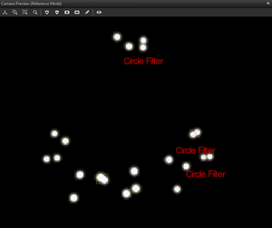](https://v20.wiki.optitrack.com/index.php?title=File:Reconstruction_Circle.png)

The circle filter omitting non-circular reflections from a 2D camera view.

**Circularity**[[edit](https://v20.wiki.optitrack.com/index.php?title=Devices_pane&action=edit&section=15)]

Default: 0.6

This setting sets the threshold of the circularity filter. Valid range is between 0 and 1; with 1 being a perfectly round reflection and 0 being flat. Using this 2D object filter, the software can identify marker reflections using the shape, specifically the roundness, of the group of thresholded pixels. Higher circularity setting will filter out all other reflections that are not circular. It is recommended to optimize this setting so that extraneous reflections are efficiently filtered out while not filtering out the marker reflections.

When using lower resolution cameras to capture smaller markers at a long distance, the marker reflection may appear to be more pixelated and non-circular. In this case, you may need to lower the circularity filter value for the reflection to be considered as a 2D object from the camera view. Also, this setting may need to be lowered when tracking non-spherical markers in order to avoid filtering the reflections.

**Intrusion Band**[[edit](https://v20.wiki.optitrack.com/index.php?title=Devices_pane&action=edit&section=16)]

Default: 0.5 (Pixels)

The intrusion band feature allows cameras to recognize reflections that are about to be merged and filter them out before it happens. This filter occurs before the circularity filter, and these reflections are rejected before the thresholded pixels merge. This is useful for improving the accuracy of the tracking, because bright pixels from close by reflections may slightly shift the centroid locations. The intrusion band value is added to the calculated radius of detected markers to establish a boundary, and any extraneous reflections intruding the boundary is considered as the intrusion and gets omitted. When an intrusion happens, both intruding reflection and detected marker reflection will be filtered out.

**Garyscale Floor**[[edit](https://v20.wiki.optitrack.com/index.php?title=Devices_pane&action=edit&section=17)]

Default: 48

The grayscale floor setting further darkens pixels with lower brightness intensity values.

**Object Margin**[[edit](https://v20.wiki.optitrack.com/index.php?title=Devices_pane&action=edit&section=18)]

Default: 2 (Pixels)

The object margin adds an additional margin on top of the intrusion band for filtering out merged reflections. Lowering this value will better detect close-by reflections, but may decrease the accuracy of the centroid positions as a tradeoff.

*Display Options[*[*edit*](https://v20.wiki.optitrack.com/index.php?title=Devices_pane&action=edit&section=19)*]*

**Name**[[edit](https://v20.wiki.optitrack.com/index.php?title=Devices_pane&action=edit&section=20)]

Sets the name for the selected camera group.

**Camera Color**[[edit](https://v20.wiki.optitrack.com/index.php?title=Devices_pane&action=edit&section=21)]

Sets the color for camera group members as they appear in the 3D viewport. Color values are input as standard RGB triplets.

**Visible Cameras**[[edit](https://v20.wiki.optitrack.com/index.php?title=Devices_pane&action=edit&section=22)]

Selects whether cameras in the group are displayed in the viewport.

**Show Volume**[[edit](https://v20.wiki.optitrack.com/index.php?title=Devices_pane&action=edit&section=23)]

Selects whether the capture volume (defined as capable of tracking a single marker) is displayed in the viewport. Enabling this will allow the volume to be displayed as a wire cage around the ground plane where multiple cameras fields of view intersect. Valid options are True, False (default).

**Camera FOV**[[edit](https://v20.wiki.optitrack.com/index.php?title=Devices_pane&action=edit&section=24)]

Selects whether camera FOVs are displayed in the viewport. Camera FOV accurately depicts the frustum angles, while depth is artificially capped. Actual depth may vary depending on camera settings and marker size. Enabling this feature can be beneficial in volume visualization for creation and adjustment. Valid options are True (default), False.

**Camera Overlap**[[edit](https://v20.wiki.optitrack.com/index.php?title=Devices_pane&action=edit&section=25)]

Sets the minimum camera overlap necessary for a region to be visualized as part of the capture volume. Higher numbers represent more camera coverage, but they will tend to reduce the size of the visualized capture volume. Valid range is 1 to 25 (default 3).

**Volume Resolution**[[edit](https://v20.wiki.optitrack.com/index.php?title=Devices_pane&action=edit&section=26)]

Sets the resolution of the capture volume visualization. A higher number represents a more detailed visualization. Valid range is 1 to 120 (default 50).

**Opacity**[[edit](https://v20.wiki.optitrack.com/index.php?title=Devices_pane&action=edit&section=27)]

Sets the opacity of the volume visualization. A value of 1 is transparent and 100 is opaque. Valid range is 1 to 100 (default 100).

**FOV Intensity**[[edit](https://v20.wiki.optitrack.com/index.php?title=Devices_pane&action=edit&section=28)]

Sets the opacity of the FOV visualization. A higher value represents a more opaque volume visualization. Valid range is 1 to 100 (default 50).

*Advanced[*[*edit*](https://v20.wiki.optitrack.com/index.php?title=Devices_pane&action=edit&section=29)*]*

**Synchronization Control**[[edit](https://v20.wiki.optitrack.com/index.php?title=Devices_pane&action=edit&section=30)]

Determines how late camera frames are dealt with. Timely Delivery will drop late frames, which is ideal for real-time applications where data completeness is secondary to timeliness. Complete Delivery will hold up processing of frames when a frame is late. Automatic, which is the default and recommended setting, runs in Timely Delivery mode until it gets a non-trivial percentage of late frames, at which point it will automatically switch to Complete Delivery.

**Fan Mode**[[edit](https://v20.wiki.optitrack.com/index.php?title=Devices_pane&action=edit&section=31)]

Provides an option to turn off the camera fan during recording, for S250e cameras only.

**Shutter Offset**[[edit](https://v20.wiki.optitrack.com/index.php?title=Devices_pane&action=edit&section=32)]

Delays the shutter timing of selected tracking camera group for N microseconds.

**Mask Regions**[[edit](https://v20.wiki.optitrack.com/index.php?title=Devices_pane&action=edit&section=33)]

* **Mask Width (pixels):**

Sets the extra pixel coverage (width) for masking visible markers when the mask visible function is used. A larger number will block a wider grouping of pixels simultaneously. Valid range is determined by the resolution of the cameras.

* **Mask Height (pixels):**

Sets the extra pixel coverage (height) for masking visible markers when the mask visible function is used. A larger number will block a wider grouping of pixels simultaneously. Valid range is determined by the resolution of the cameras.

Device Properties: Camera[[edit](https://v20.wiki.optitrack.com/index.php?title=Devices_pane&action=edit&section=34)]

[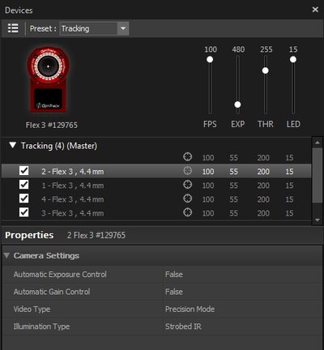](https://v20.wiki.optitrack.com/index.php?title=File:Devices_SingleCameraProperties_20.png)

Single camera configurable properties.

The following properties can be configured when a Camera is selected from the Devices pane. Please note that the available properties might be slight different on different camera models.

*Camera Settings[*[*edit*](https://v20.wiki.optitrack.com/index.php?title=Devices_pane&action=edit&section=35)*]*

**Gain**[[edit](https://v20.wiki.optitrack.com/index.php?title=Devices_pane&action=edit&section=36)]

Sets the imager gain level for the selected cameras. Gain settings can be adjusted to amplify or diminish the brightness of the image. This setting can be beneficial when tracking at long ranges. However, note that increasing the gain level will also increase the noise in the image data and may introduce false reconstructions. Thus, before deciding to change the gain level, adjust the camera settings first to optimize the image clarity.

**Video Type**[[edit](https://v20.wiki.optitrack.com/index.php?title=Devices_pane&action=edit&section=37)]

Sets the [video type](https://v20.wiki.optitrack.com/index.php?title=Camera_Video_Types#Video_Types) of the selected camera.

**Illumination Type**[[edit](https://v20.wiki.optitrack.com/index.php?title=Devices_pane&action=edit&section=38)]

Sets the illumination to either Strobed or Continuous. Strobed illumination will output more light with equivalent power when compared to Continuous and is the ideal choice for standard motion capture volumes. Continuous is ideal for volumes where external IR interference is potentially an issue (e.g. with IR actuated stereovision systems that cannot synchronize to the OptiTrack cameras, or when other volumes may be within line of sight).

**Filter Switch**[[edit](https://v20.wiki.optitrack.com/index.php?title=Devices_pane&action=edit&section=39)]

Sets the camera to view either visible or infrared light on cameras equipped with a Filter Switcher. Infrared Spectrum should be selected when the camera is being used for marker tracking applications. Visible Spectrum can optionally be selected for full frame video applications, where external, visible spectrum lighting will be used to illuminate the environment instead of the camera’s IR LEDs. Common applications include reference video and external calibration methods that use images projected in the visible spectrum.

**Automatic Exposure Control**[[edit](https://v20.wiki.optitrack.com/index.php?title=Devices_pane&action=edit&section=40)]

(Default: False) Enables cameras to automatically adjust its camera exposure setting depending on the contrast level within the detected image. This feature is available only in Flex 3's and Duo/Trio tracking bars.

**Automatic Gain Control**[[edit](https://v20.wiki.optitrack.com/index.php?title=Devices_pane&action=edit&section=41)]

(Default: False) Thisl feature adjust the camera gain level automatically for best tracking. This feature is available only in Flex 3's and Duo/Trio tracking bars.

Device Properties: Force Plate / Force Plate Group[[edit](https://v20.wiki.optitrack.com/index.php?title=Devices_pane&action=edit&section=42)]

[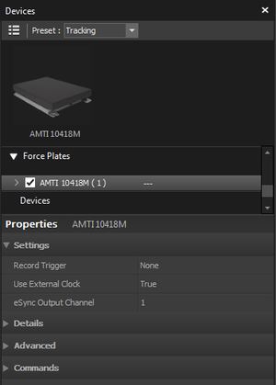](https://v20.wiki.optitrack.com/index.php?title=File:DevicesPane_FP_20.png)

Force plate group configurable properties.

The following properties can be configured when a force plate or a *Force Plates* group is selected from the **Devices pane**.

*Device Properties: Force Plate[*[*edit*](https://v20.wiki.optitrack.com/index.php?title=Devices_pane&action=edit&section=43)*]*

[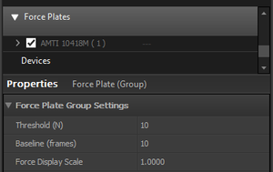](https://v20.wiki.optitrack.com/index.php?title=File:DevicesPane_FPgroup_20.png)

Force plate group configurable properties.

**Record Trigger**[[edit](https://v20.wiki.optitrack.com/index.php?title=Devices_pane&action=edit&section=44)]

Configures whether if the force plate is triggered at recording. Set this to *Device* only when synchronizing to force plate via the triggered sync or the free run sync.

**Use External Clock**[[edit](https://v20.wiki.optitrack.com/index.php?title=Devices_pane&action=edit&section=45)]

Set this to true for force plates that are synchronized via external clock signal from the eSync.

**eSync Output Channel**[[edit](https://v20.wiki.optitrack.com/index.php?title=Devices_pane&action=edit&section=46)]

Set this to the output port number of the eSync that the force plate amplifier is connected to.

*Device Properties: Force Plate Group[*[*edit*](https://v20.wiki.optitrack.com/index.php?title=Devices_pane&action=edit&section=47)*]*

**Threshold**[[edit](https://v20.wiki.optitrack.com/index.php?title=Devices_pane&action=edit&section=48)]

Minimum threshold, in N, force required for the resultant force to be displayed in the view port.

**Baseline (frames)**[[edit](https://v20.wiki.optitrack.com/index.php?title=Devices_pane&action=edit&section=49)]

Sets the length of initial recording, baseline, frames to be used as the reference *zero* samples in C3D files. During the initial frames, no load should be applied to the plates.

**Force Display Scale**[[edit](https://v20.wiki.optitrack.com/index.php?title=Devices_pane&action=edit&section=50)]

Adjusts the size of the resultant force vector displayed in the 3D viewport.

Device Properties: NI-DAQ Device[[edit](https://v20.wiki.optitrack.com/index.php?title=Devices_pane&action=edit&section=51)]

The following properties can be configured when a NI-DAQ device is selected from the Devices pane.

[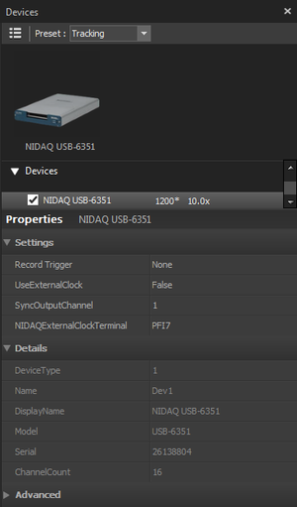](https://v20.wiki.optitrack.com/index.php?title=File:ND_DAQProperties.png)

NI-DAQ device properties displayed in the **Devices pane**.

**Record Trigger**[[edit](https://v20.wiki.optitrack.com/index.php?title=NI-DAQ_Setup&action=edit&section=T-1)]

This setting determines how the recording of the selected NI-DAQ device will be triggered. Setting it to *True* will use hardware data packets to trigger the record start frame. Setting it to *False* will trigger the recording when Motive starts capturing data.

**Use External Clock**[[edit](https://v20.wiki.optitrack.com/index.php?title=NI-DAQ_Setup&action=edit&section=T-2)]

Sets whether an external clock signal is integrated. *For precise synchronization using the internal clock signal sync, set this to true.*

* **True:** Setting this to true will configure the selected NI-DAQ device to synchronize with an inputted external sample clock signal. The NI-DAQ must be connected to an external clock output of the eSync on one of its digital input terminals. The acquisition rate will be disabled since the rate is configured to be controlled by the external clock signal.
* **False:** NI-DAQ board will collect samples in 'Free Run' mode at the assigned *Acquisition Rate*.

**Acquisition Rate**[[edit](https://v20.wiki.optitrack.com/index.php?title=NI-DAQ_Setup&action=edit&section=T-3)]

When the *Use External Clock* setting is set to False, acquisition rate for NI-DAQ device(s) can be set individually in the **Devices pane**. You can modify the multiplier to change the acquisition rate to multiples (up to X16) of the camera frame rate. This sets the acquisition rate of the NI-DAQ devices when synchronizing without an external clock signal from the eSync. In this case, the devices will be running at the *Free Run* mode, and the NI-DAQ device(s) and the cameras will be triggered simultaneously but they will capture at their own sampling rate. Synchronization drift will be introduced over time when using the free run mode.

**NIDAQ External Clock Terminal**[[edit](https://v20.wiki.optitrack.com/index.php?title=NI-DAQ_Setup&action=edit&section=T-4)]

Name of the NI-DAQ digital I/O terminal that the external clock (TTL) signal is inputted to.

**Samples Per Event**[[edit](https://v20.wiki.optitrack.com/index.php?title=Devices_pane&action=edit&section=52)]

*[Advanced]* *Modifying this value is not recommended*. The Samples Per Event property determines how many samples are collected from the NI-DAQ device onto the hardware buffer before it gets delivered and plotted on Motive. When a very large number of analog channels are integrated in Motive, this setting may need to be increased to prevent dropped samples, but in most cases, the default setting should work fine.

Device Properties: NI-DAQ Channel[[edit](https://v20.wiki.optitrack.com/index.php?title=Devices_pane&action=edit&section=53)]

The following properties can be configured a analog input channel under a NI-DAQ device is selected from the Devices pane.

[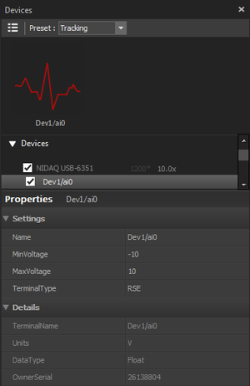](https://v20.wiki.optitrack.com/index.php?title=File:ND_ChannelProperties.png)

NI-DAQ device *channel* properties displayed in the **Devices pane**.

Depending on the model, NI-DAQ devices may have different sets of allowable input types and voltage ranges for their analog channels. Refer to your NI-DAQ device User's Guide for detailed information about supported signal types and voltage ranges.

**Min Voltage**[[edit](https://v20.wiki.optitrack.com/index.php?title=NI-DAQ_Setup&action=edit&section=T-1)]

(Default: -10 volts) Configure the terminal's minimum voltage range.

**Max Voltage**[[edit](https://v20.wiki.optitrack.com/index.php?title=NI-DAQ_Setup&action=edit&section=T-2)]

(Default: +10 volts) Configure the terminal's maximum voltage range.

**Terminal Type**[[edit](https://v20.wiki.optitrack.com/index.php?title=NI-DAQ_Setup&action=edit&section=T-3)]

Configures the measurement mode of the selected terminal. In general, analog input channels with screw terminals use the single-ended measurement system (RSE), and analog input channels with BNC terminals use the differential (Diff) measurement system. For more information on these terminal types, refer to [NI documentation](http://www.ni.com/white-paper/3394/en/#toc3).

* **Terminal: RSE** Referenced single ended. Measurement with respect to ground (e.g. AI_GND) (Default)
* **Terminal: NRSE** NonReferenced single ended. Measurement with respect to single analog input (e.g. AISENSE)
* **Terminal: Diff** Differential. Measurement between two inputs (e.g. AI0+, AI0-)
* **Terminal: PseudoDiff** Differential. Measurement between two inputs and impeded common ground.

[Category](https://v20.wiki.optitrack.com/index.php?title=Special:Categories):

* [Motive UI](https://v20.wiki.optitrack.com/index.php?title=Category:Motive_UI)
* This page was last modified on 14 May 2018, at 11:48.
* All data and information contained in or disclosed by this wiki is proprietary information of NaturalPoint Corporation and all rights therein are expressly reserved. By accepting this material the recipient agrees that this material and the information contained therein is held in confidence and in trust and will not be used, copied, reproduced in whole or in part, nor its contents revealed in any manner to others without the express written permission of NaturalPoint Corporation. Information in this document is preliminary and subject to change and does not represent a commitment on the part of NaturalPoint Corporation.

[Helpdesk](http://help.naturalpoint.com/) [Forums](https://forums.naturalpoint.com/) [Contact Us](https://www.optitrack.com/contact/)

[b](https://www.facebook.com/OptiTrack/)[a](https://twitter.com/optitrack)[r](https://www.youtube.com/user/NaturalPointInc)

2016 NaturalPoint, Inc. DBA OptiTrack